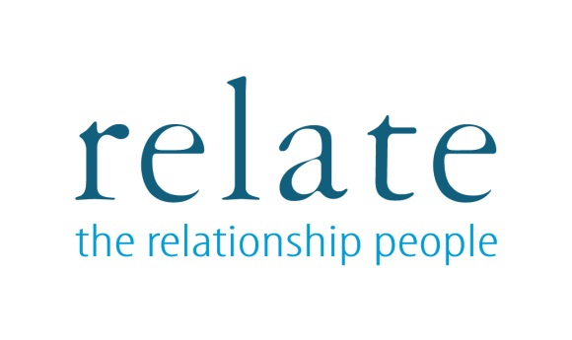
BOOKING FORM
Counselling Skills for Non-Counsellors

Date of Course

Name
Address (including post code)
Telephone number
Email
Invoice details (if required)

Payment can be made by:-
- Cheque (payable to ‘Relate Coventry & Warwickshire’) at 1110A Elliot Court, Coventry Business Park, Herald Avenue, Coventry CV5 6UB.
- Credit/debit card. If making a card payment, please phone us on 024 7622 5863 and we can take payment over the phone.

