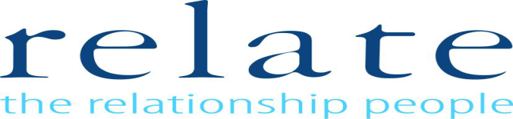
Counselling Skills for Non-Counsellors

An excellent introduction to counselling skills
The course will enable learners to develop skills in helping others by introducing some of the key counselling skills that support the helping process.
This course is widely applicable to many professionals who listen to people and provide help and support including appropriate signposting. Previous attendees have included social workers, support workers, volunteers, health professionals and private sector workers.
Learning Outcomes
On completion of the training participants should be able to:
•Understand and use the skills necessary for the management of sessions using counselling skills
•Recognise the process of change and loss
•Demonstrate some of the ethical issues and the need for support in activities using counselling skills
•Explore the importance of self-awareness and understanding limitations when using counselling skills in the helping relationship
•Recognise the impact various communication styles can have on interpersonal relationships
•Successfully begin, conduct and end a session with appropriate signposting if required
Participants:
•Minimum 8 (for single organisation delivery)
•Maximum 12
Dates: Cost:
Monday – 10am – 4pm One day programme £120.00
23rd October, 2017
Location:
Car parking is available
Any questions?
Email: zoe.baines@relatecoventry.org

Relate Coventry & Warwickshire
1110a Elliott Court
Herald Avenue
Coventry
CV5 6UB

